1. Review from p.21 to p.30 in the text book.

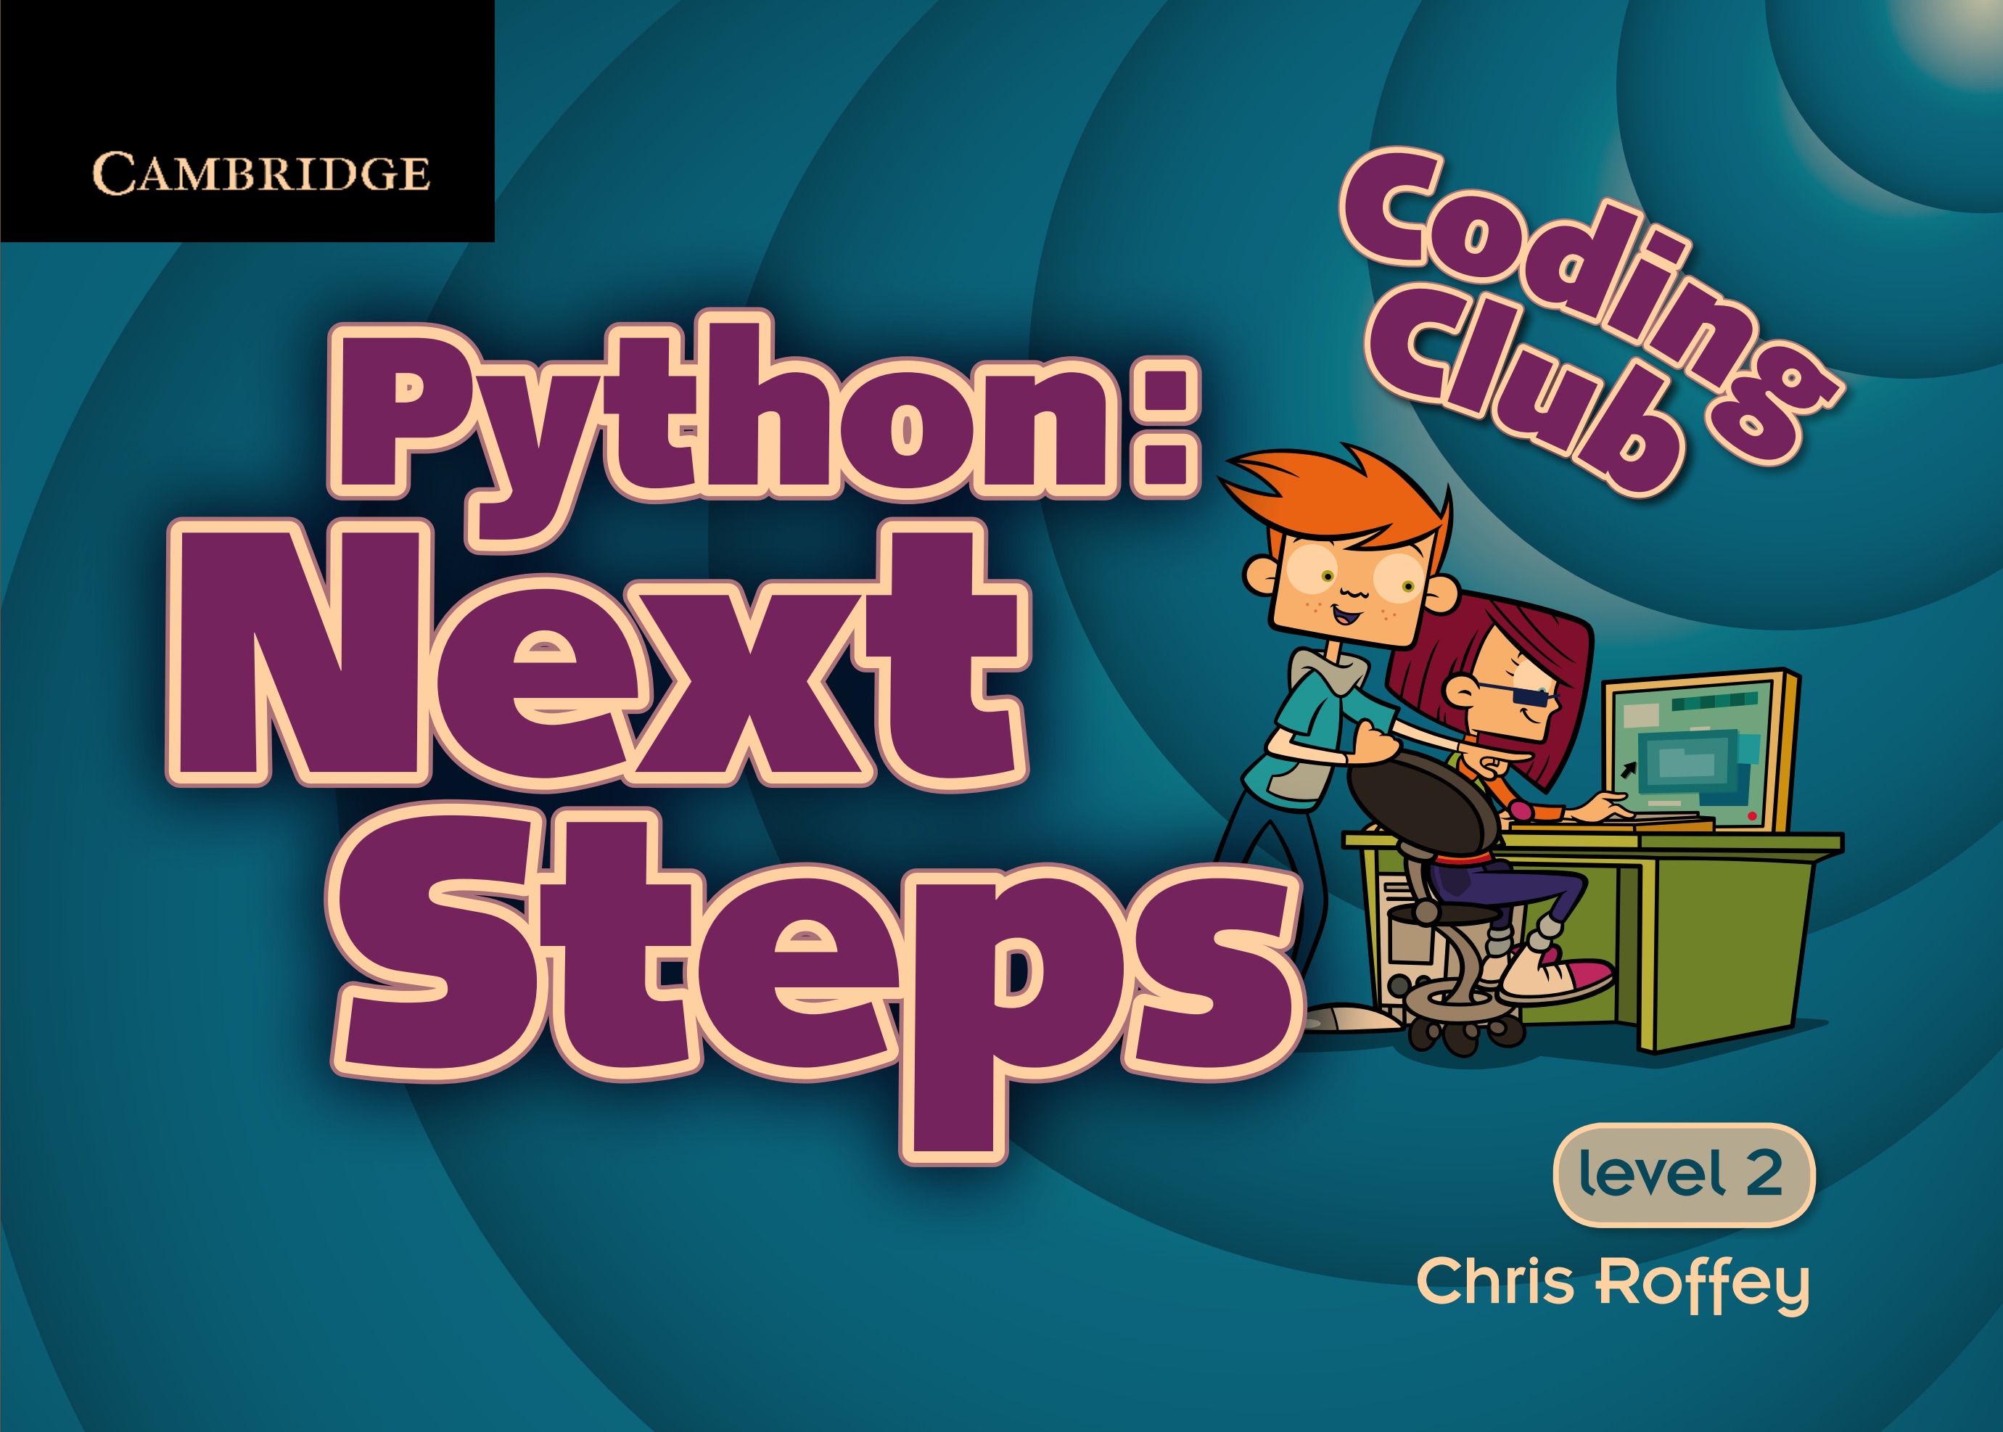

1. Summarize the concepts you think are important among those contents.